**EXP:NO:12**

Demonstrate virtualization by Installing Type-2 Hypervisor in your device, create and configure VM image with a Host Operating system (Either Windows/Linux), using VMware workstation.

**AIM:**

To demonstrate virtualization by installing a Type-2 hypervisor (VMware Workstation) and creating a virtual machine with a guest OS (Windows/Linux).

**PROCEDURE:**

1. Install VMware Workstation on the host machine.
2. Launch VMware and configure default VM storage settings.
3. Create a new VM using the OS installation media and assign VM name/location.
4. Allocate hardware resources (RAM, CPU, disk) and configure optional settings.
5. Install the guest OS and VMware Tools to enable smooth host-guest integration.

**OUTPUT:**

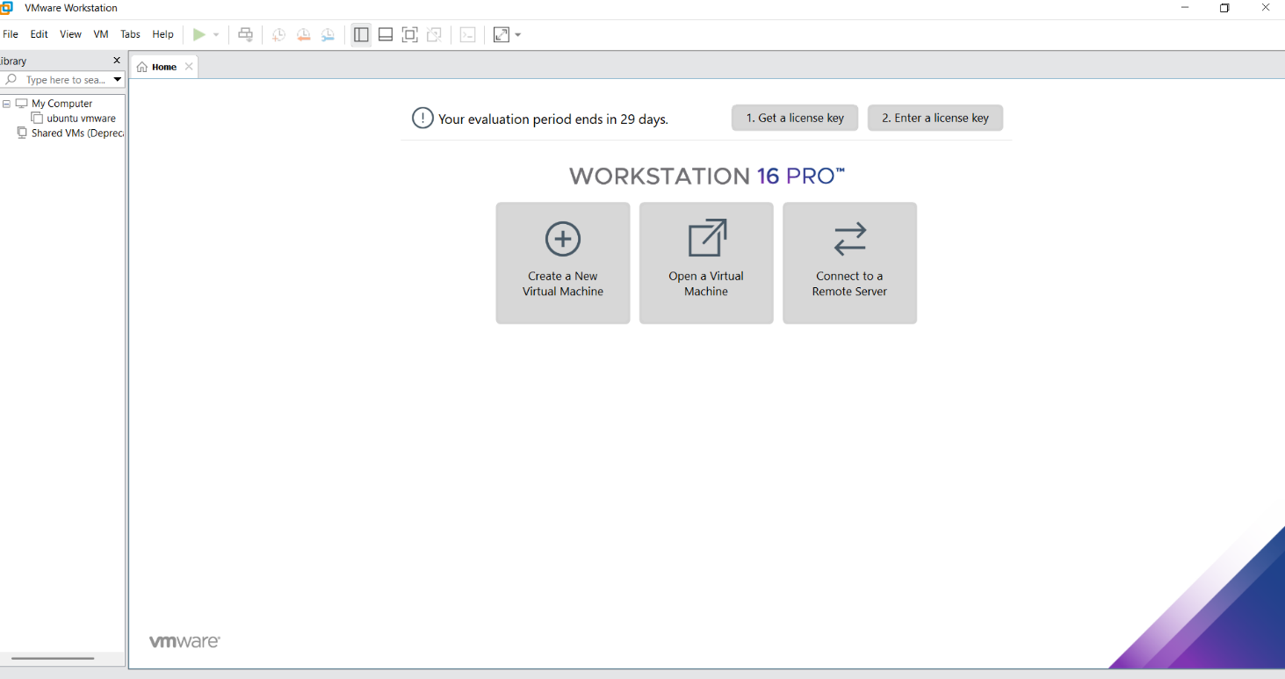

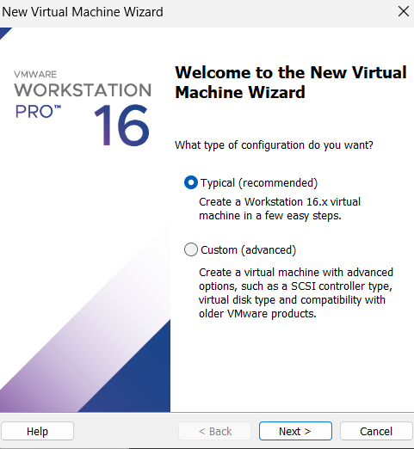

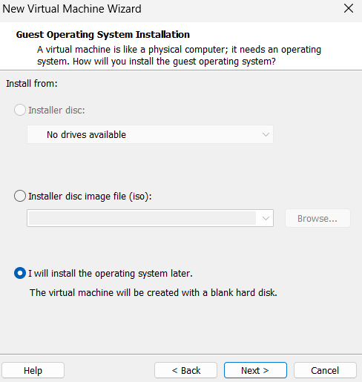

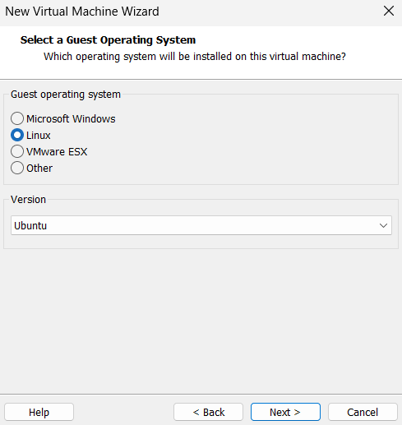

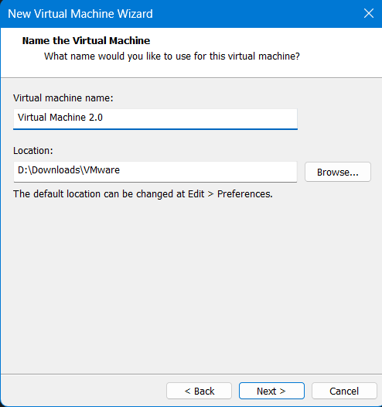

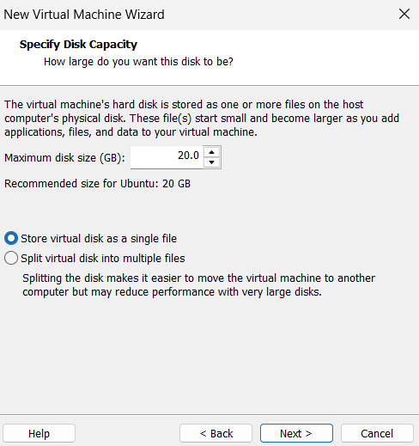

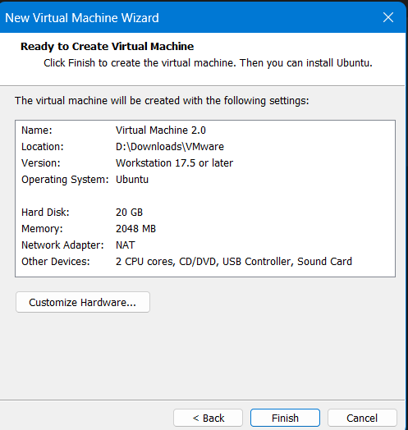

**RESULT:**

VMware Workstation was installed successfully, a VM was created, and the guest OS ran properly, demonstrating virtualization with isolated resources.